
Spelling Words
- went
- tell
- pet
- job
- fog
- not
- tug
- hut
- tub
- bun
- fix
- has
- another
- move
- year
Vocabulary Words
share- to give parts of what one person has to others
wonderful- very good; amazing
company- a friend or friends; guest
delighted- very pleased
thinning – making or becoming think
enjoyed- got joy or pleasure from

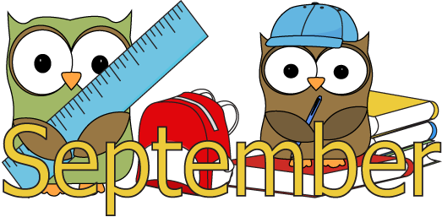

Upcoming events

Sept. 1 –HS VB @ Goodland
Sept. 3 – JH VB & VB vrs. Greely Co.
-BG XC @ Norton
Sept. 4 – HS FB @ Decatur Co.
Sept. 7 – No School Labor Day
Sept. 28 – No School- Teacher In-service

Phonics | Writing | Comprehension | Math | Science | Social Studies
- Short /e/o/u/ | - Personal Narrative: Description | - Story Structure: Plot | - Place Value | - Earth’s Resources | - Rules and Responsibility  

I can’t believe we are ready for our second full week of school! Be sure when your child is reading their book cart books that they are sounding out the words they don’t know and not just guessing the words. Also I ask that everyone reads for 15 minutes every night. They can read their book cart book and then they may read another book. You can just write down their total time that they read or feel free to write down the other book that they read in the same line as the book cart book.

Lichelle Baar (785-657-3254)
libaar@hoxie.org

